- EXPRESSION OF INTEREST (EOI)

EOI Reference #: ASMC-WRTI-EOI-2024-001
Title: SM701A – CGS Tow and installation Operation Simulations
Project: West White Rose CGS Tow-out & Installation

Issue Date: January 29, 2024
Closing Date: February 16, 2024

GENERAL
Aker Solutions Marine Contractors Limited (ASMC) hereby invites interested parties to submit an Expression of Interest (EOI) related to the future Requests for Tender for the following Scope of Work in connection with ASMC Concrete Gravity Structure (CGS) Tow-out and Installation Scope of Work for the Cenovus West White Rose Project in Newfoundland and Labrador, Canada.

BENEFITS COMMITMENTS
ASMC is committed to providing full and fair opportunities to commercially competitive Canadian companies with first consideration given to those from Newfoundland and Labrador. At the Pre-Qualification and ITT stages, companies will be required to complete Canada/Newfoundland & Labrador Benefits questionnaires to acknowledge their willingness to comply with the White Rose Canada-Newfoundland and Labrador Benefits Plan.

EQUAL OPPORTUNITY
ASMC is an equal opportunity employer and supports diversity in the workplace. Successful suppliers and subcontractors to ASMC will be required to undertake a commitment to support diversity in execution of work on the West White Rose Project.

SCOPE OF WORK

The Scope of Work includes simulation of various phases of the WWRP CGS Tow and installation operations to provide familiarization and training to key operational personnel.

The program will include simulations of the following key operations:
- Float-out of Dock
- Towing Through Dredged Channels
- Inshore Towing
- Offshore Towing
- CGS Positioning for Installation

Figure 1 – CGS Rendering

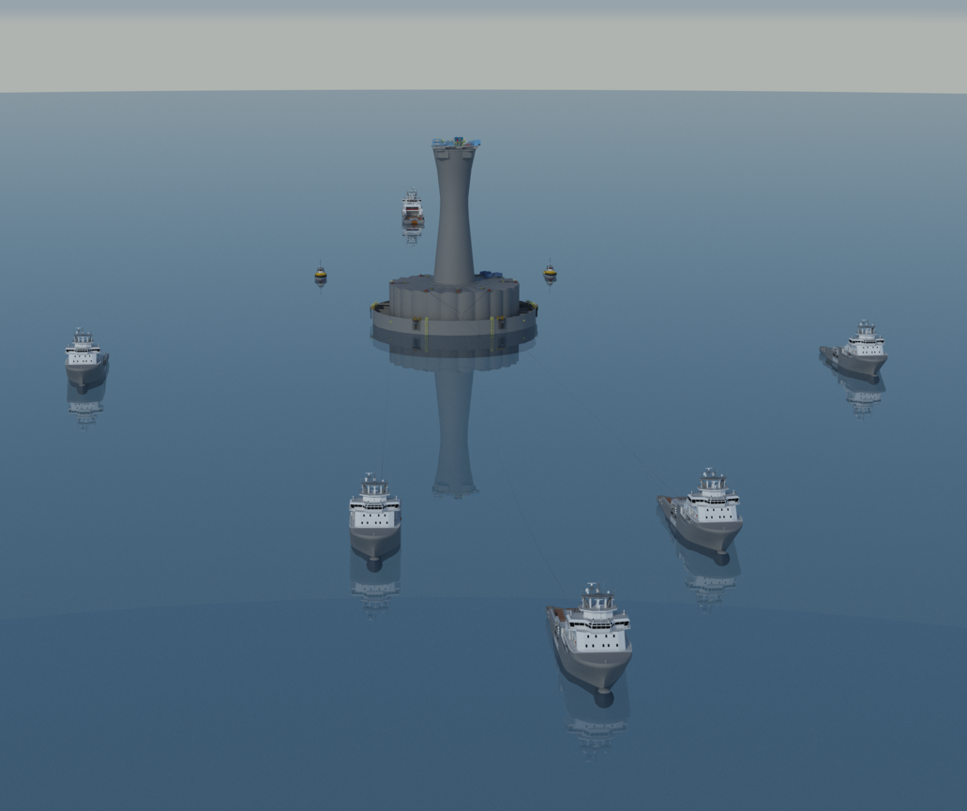
Figure 2 – Inshore Tow

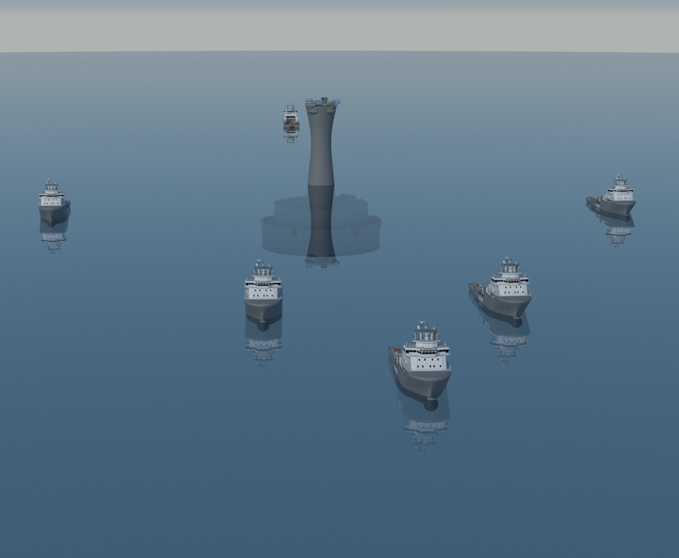
Figure 3 – Offshore Tow
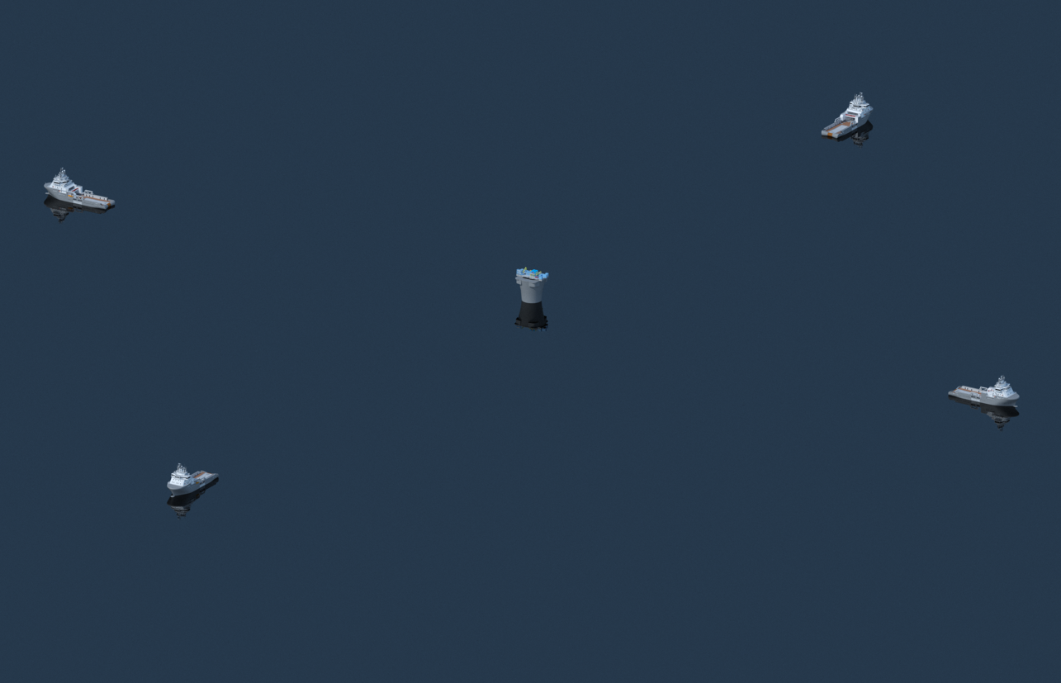
Figure 4 – Positioning for Installation

In General, the simulator shall meet the following key functional requirements:
- Real-time visualization of the operations shall be provided from a specified location (e.g., lead tug).
- Simulations shall aim to establish a realistic behaviour of the CGS, towing vessels and winches through the various phases of operations.
- CGS floating characteristics (hydrostatic and hydrodynamic) shall be accurately modelled using data furnished by ASMC.
- ASMC personnel will coordinate with supplier/subcontractor during simulation planning including calibration of behavioural characteristics of the CGS, vessels and land-based winches.
- 5-off land-based winches shall operate simultaneously (applicable for float-out phase only).
- Up to 8-off vessels (harbour tugs and/or anchor handling tugs) may operate simultaneously.
- Towing vessels/anchor handling tugs can operate with towline connected to the CGS and a bowline connected to seabed anchors.
- Simulations shall have the capacity to be interactive; with real time control of land-based winch pulling forces and tug pulling/winching & pushing forces and position/heading.
- Control of the winches and towing vessels is to be performed by the simulator operator following the instructions of ASMC supplied Operations Manager/Tug Coordinators.
- Simulations shall take into account the following loads on the CGS:
  - Wave drift
  - Current
  - Wind
  - Tug towlines / winch lines
- A navigation screen suited for typical multi-vessel marine operations shall be included.
- Full simulation output time series of key parameters (e.g., position, heading, motions, environmental loads, etc.) shall be recorded.

NOTE: During the EOI process; interested Respondent’s may be subjected to technical, quality and/or safety qualifications and or audits for the purposes of validating their operations and procedures.

SCHEDULE AND DELIVERY
It is estimated that the simulation program will require 8 to 10 simulator days and be completed in November/December 2024.

SUBMISSION REQUIREMENTS

As part of the submission requirements, suppliers are requested to provide Aker Solutions Marine Contractors Limited with the following answers and/or information:
- Please provide a brief outline of the following company information:
  - Copy of Certificate of Incorporation.
  - Company Name and Address.
  - Single Point of Contact, c/w contact details.
- Please describe simulation facility including numerical modelling software/methods and visual representations/displays.

- Please describe experience in conducting simulation programs for novel-shaped floaters (e.g., concrete gravity-based structures) and muti-vessel towing operations.

RESPONSE REQUIREMENTS

Suppliers are to respond to the following e-mail address: ASMC.WRTI_Procurement@akersolutions.com

on or before the closing date noted above.

The subject line of the email must contain the following:
EOI REFERNCE NUMBER – TITLE – Supplier Company Name

Suppliers that have not been pre-qualified will be required to do so before the formal RFQ/Tender/Bid packages.

If you have any questions regarding this announcement, please contact:

Tanya O’Neill
Contracts Manager
Aker Solutions Marine Contractors Limited
tanya.oneill@akersolutions.com

